|  |
| --- |
|  |
| Knowledge Document |
| Run Book for EDW PRICING (Pricing External Systems) |

|  |
| --- |
| [This document contains proprietary information of HCL Technologies Ltd. and the filled in information would be for the exclusive use of designated SBD and HCL only. No part of this document may be reproduced, stored, copied, or transmitted in any form or by means of electronic, mechanical, photocopying or otherwise, without the express consent of SBD and/or HCL Technologies Ltd.] |

**Revision History**

|  |  |  |  |
| --- | --- | --- | --- |
| Version No. | Date | Prepared/Modified by | Significant Changes |
| 1 | 07/18/2022 | Kumar Sambhav | Initial version |
| 2 | 07/18/2022 | Nilanjan Patra | Initial version |

**Table of Contents**

1. INTRODUCTION 1

1.1. Purpose of Document 1

1.2. Scope of Document 1

1.3. Audience 1

2. APPLICATION FUNCTIONAL OVERVIEW 2

2.1. Application Functionality 2

2.2. Functional Context Diagram 3

2.3. Talend Job Names 4

2.4. Support Team Structure 4

# INTRODUCTION

* 1. Purpose of Document

This document provides the functional and technical overview of ***EDW Pricing (Sources Included:***  ***USPOS, Barometer, WebPrice, PriceFX, RSA Bible, SSA, DataMind)*** along with operational information that would be required to support the application on a day-to-day basis. Objective for preparing this document is to capture comprehensive knowledge about ***EDW Pricing Data Migration in*** single place. Thus, reducing effort of readers to refer multiple documents

* 1. Scope of Document

This document covers the following about ***EDW Pricing (Pricing External Systems)***

The Sources included in ***EDW Pricing*** are: ***USPOS,Barometer,WebPrice,PriceFX,RSA Bible,SSA,DataMind  
Pricing External Systems***

1. Functional overview
2. Technical overview
3. Operational/Support information
   1. Audience

This document could be referred by following ─

1. Project Manager
2. Business Analyst
3. Developers
4. Testers
5. Support Personnel

# APPLICATION FUNCTIONAL OVERVIEW

* 1. Application Functionality

Serve the business functionality of ***EDW Pricing*** ***Data Migration from Zone-3 to Zone-4 Team*** and Various business functions supported and handled by ***EDW Pricing*** ***Data Migration Team***.

In EDW PRICING Data Migration Data from Zone3 to Consolidated layer (Zone – 4)

This process involves the following:

**Preparation of Mapping Document.**

1. Need to get LDM attributes
2. Identify mapping for the defined attributes
3. Approval on the mapping from Source SME

**Building the DBT model using the mapping document (approved by source SME).**

1. Build DBT model using mapped attributes
2. DBT Model execution to load the data from Zone3 to Zone4.

**Testing the loaded data.**

Testing Strategy:

1. Unit Testing.

2. Evidence Documents

3. UAT (Performed by Business user).

**Evidence Document Location:**

|  |  |  |
| --- | --- | --- |
| **TMC TASK** | **SIT PATH** | **UT Path** |
| EDW_PRC_BAROMETER | [GTS SIT Documents](https://apc01.safelinks.protection.outlook.com/?url=https%3A%2F%2Fecentral.sharepoint.com%2F%3Af%3A%2Fr%2Fsites%2FCaspian-EDW%2FShared%2520Documents%2FGeneral%2FData%2520Model%2FPricing%2520LDM%2520-%2520Consolidation%2520Zone%2520(EDW)%2FGTS%2520SIT%2520Documents%3Fcsf%3D1%26web%3D1%26e%3DZvZSi7&data=05%7C01%7Ckumar.sambhav%40hcl.com%7C9474465e1403406f890808da97adca2c%7C189de737c93a4f5a8b686f4ca9941912%7C0%7C0%7C637989069922215606%7CUnknown%7CTWFpbGZsb3d8eyJWIjoiMC4wLjAwMDAiLCJQIjoiV2luMzIiLCJBTiI6Ik1haWwiLCJXVCI6Mn0%3D%7C3000%7C%7C%7C&sdata=YREG6iDsKeUIV3J2lNxp8O3F08Fp0pgjek8QI30XNcw%3D&reserved=0) | [Pricing GTS UT Documents](https://apc01.safelinks.protection.outlook.com/?url=https%3A%2F%2Fecentral.sharepoint.com%2F%3Af%3A%2Fr%2Fsites%2FCaspian-EDW%2FShared%2520Documents%2FGeneral%2FData%2520Model%2FPricing%2520LDM%2520-%2520Consolidation%2520Zone%2520(EDW)%2FPricing%2520GTS%2520UT%2520Documents%3Fcsf%3D1%26web%3D1%26e%3DA6AGhu&data=05%7C01%7Ckumar.sambhav%40hcl.com%7C9474465e1403406f890808da97adca2c%7C189de737c93a4f5a8b686f4ca9941912%7C0%7C0%7C637989069922215606%7CUnknown%7CTWFpbGZsb3d8eyJWIjoiMC4wLjAwMDAiLCJQIjoiV2luMzIiLCJBTiI6Ik1haWwiLCJXVCI6Mn0%3D%7C3000%7C%7C%7C&sdata=ly%2FocycBuf95OoIRD43VV0sBb%2F6Ob91U5M9PNl7T2eE%3D&reserved=0) |
| EDW_PRC_PRICEFX | GTS SIT Documents | Pricing GTS UT Documents |
| EDW_PRC_DATAMIND | GTS SIT Documents | Pricing GTS UT Documents |
| EDW_PRC_WEBPRICE | GTS SIT Documents | Pricing GTS UT Documents |
| EDW_PRC_SSACOMPETITIVEINTELLIGENCE | GTS SIT Documents | Pricing GTS UT Documents |
| EDW_PRC_SFTPGTSI | GTS SIT Documents | Pricing GTS UT Documents |
| EDW_PRC_USPOS | GTS SIT Documents | Pricing GTS UT Documents |

**Mapping Document Location :**[**EDW Integration - Business Review - All Documents (sharepoint.com)**](https://ecentral.sharepoint.com/sites/Caspian-EDW/Shared%20Documents/Forms/AllItems.aspx?FolderCTID=0x0120005203C43A07D362438EAAC71AFE8D659A&OR=Teams%2DHL&CT=1633665181490&id=%2Fsites%2FCaspian%2DEDW%2FShared%20Documents%2FGeneral%2FData%20Model%2FPricing%20LDM%20%2D%20Consolidation%20Zone%20%28EDW%29%2FBusiness%20Review&viewid=bd37b4ab%2D7b8e%2D4b34%2D834e%2D8dbe442c9669)

**AWS Secrets Information:**   
**sbd/caspian/prod/operations/db/sbd_caspian_snowflake_edw**

* 1. Functional Context Diagram

**Context Diagram**

This context diagram/Flowchart will depict the interfaces of concerned ***EDW Data Migration Team*** with various business functions. Diagram will categorically highlight the flow of data/information/reports, etc. between ***EDW Data Migration Team*** and business functions.

**HOTS KT Session Meeting Recording Details:**

|  |  |  |  |  |
| --- | --- | --- | --- | --- |
| **SL.No** | **Date** | **System** | **Meeting Recording Link** | **Passcode** |
| 1 | 20-Sep-22 | Pricing-External Systems | https://stanleyblackanddecker.zoom.us/rec/share/-HQihullvjaSvpNrZwW8_ELd25GYR2w2eN97WInMZYPu6cnSv72tTzJJMHjgcGnK.Da2rfajCcJW7pAD1 | X20#ZfA0 |
| 2 | 19-Sep-22 | Pricing-External Systems | https://stanleyblackanddecker.zoom.us/rec/share/ZykC44xJ-3g-F5vv3zp3MPAHOVdLr00_TBEWjM4vR89018RcFPycAkfHETia23Gm.j8ZZZ5zJp8Y7oaZW | r9KU6#eO |

* 1. Execution Plan Steps Along With Talend Job Names
* **Step 1:***Build team to raise Pull Request which needs to be approved by the IT OPS.*

**Feature/Main  Branch Info : *bitbucket.org:sbddatalake/sbd-edw-Pricing.git - Main Branch***

* **Step 2:   
  *IT Ops to merge (Branch_name(dev -to -main))***
* **Step 3: Execute the Following jobs for environment creation.**

|  |  |  |
| --- | --- | --- |
| **Talend Adhoc Tasks in Production (One Time Load)** | | **Execution Order** |
| 1 | EDW_ADHOC_METADATA | 1st |
| 2 | EDW_PRICING_RELEASE_PROD | 2nd |
| 3 | EDW_ADHOC_DYNAMICVIEW | 3rd |

**Job descriptions:**

1. **EDW_ADHOC_METADATA:**One time data load into meta-data table (METADATELOADDT).   
   Needs to execute only when meta data configuration changes.
2. **EDW_PRICING_RELEASE_PROD :   
   dbt run -m ReleaseDayObjects :**Required in subsequent release.This job is for table modification. (DDL & DML stmt).
3. EDW_ADHOC_DYNAMICVIEW:   
   This will dynamically create the view in consolidated layer.

**Step 4:** Execute the following jobs for Initial Manual load.  
 TMC Parameters which needs to be changed in PROD during deployment :

Caspian SNOWFLAKE CredVaultKey - sbd/caspian/prod/operations/db/sbd_caspian_snowflake_edw

Caspian Environment – PROD

Repo Branch – main

|  |  |  |  |
| --- | --- | --- | --- |
| **Initial Manual Load** | | | |
| **Regular Jobs and Their Schedule** | | | |
| **SL. No** | **Source System** | **TMC Task Name** | **Autosys Schedule Time** |
| 1 | PRICING | EDW_PRC_BAROMETER | Weekly 8:00 AM (EST) |
| 2 | PRICING | EDW_PRC_PRICEFX | Weekly 8:00 AM (EST) |
| 3 | PRICING | EDW_PRC_DATAMIND - descope | Daily 8:00 AM (EST) |
| 4 | PRICING | EDW_PRC_WEBPRICE | Daily 8:00 AM (EST) |
| 5 | PRICING | EDW_PRC_SSACOMPETITIVEINTELLIGENCE | One Time – Manual |
| 6 | PRICING | EDW_PRC_SFTPGTSI - descope | Monthly (CAD file  week1 Friday in month , US file week2 Monday in month) |
| 7 | PRICING | EDW_PRC_USPOS | Daily |

**Step 5 :** Execute the following testing scripts.

**select MODEL_NAME,LOADSTATUS,ROWREAD,ROWINSERTED,ROWUPDATED,ERROR_DESCRIPTION,job_time_start,job_time_end**

**from "TEST_EDW"."CONSOLIDATED"."LOGGING" where LID in**

**(select SID from "TEST_EDW"."CONSOLIDATED"."METADATELOADDT" where SYSTEM_NAME like '%PRICING%')**

**and MODEL_NAME like '%BAROMETER%' and ERROR_DESCRIPTION IS NULL and LOADSTATUS='END'**

**order by job_time_start desc**

* **ssssFeature/Main  Branch Info.  :**

***bitbucket.org:sbddatalake/sbd-edw-main.git*** *–   
Master Branch* ***(Not required for wave 1 deployment)****This is the production branch. Contains framework templets*

* 1. Support Team Structure

1. [CaspianRunTeam@sbdinc.com](mailto:CaspianRunTeam@sbdinc.com)
2. **EDW Pricing Build Team**

**Build Team:**

|  |  |  |
| --- | --- | --- |
| 1 | Nilanjan Patra | samiuddinahmed.moham@hcl.com |
| 2 | Dheebiga R | dheebiga.r@hcl.com |
| 3 | Samudrala Sai Kiran | samudralasai.kiran@hcl.com |

**Consumer Team from *Pricing External Systems*:**

|  |  |  |
| --- | --- | --- |
| 1 | Meenakshi Sundaram | MeenakshiSundaram.Sivaramakrishnan@sbdinc.com |
| 2 | Pablo Perez | Pablo.Perez@sbdinc.com |
| 3 | Jino Jose | Jino.Jose@sbdinc.com |
| 4 | Deepak Mahendarkar | Deepak.Mahendarkar@sbdinc.com |

**SBD Caspian Team**: [SBD-Caspian-Notify@sbdinc.com](mailto:SBD-Caspian-Notify@sbdinc.com)

SLA: - TBD with Caspian Team

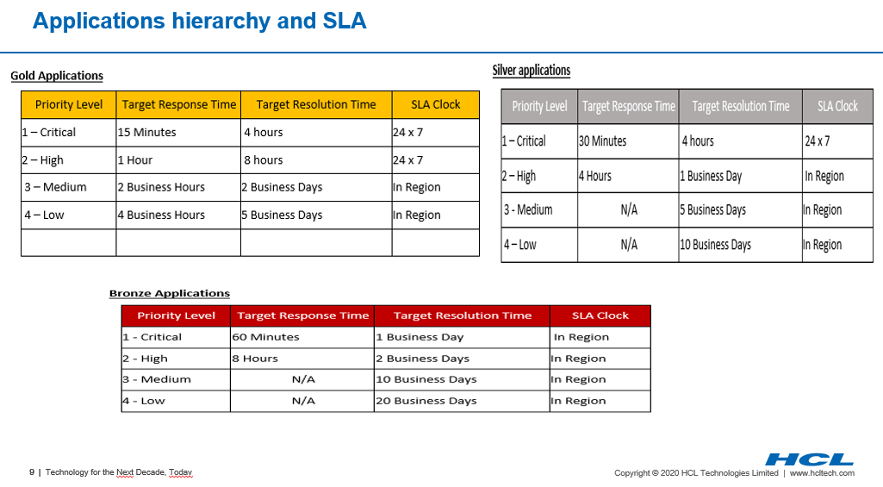

**DOCUMENT SIGN OFF**

|  |  |
| --- | --- |
| Authors | Kumar Sambhav |
| HCL Reviewers | Sudheer Nath, Surajit Chatterjee, Run Team |
| SBD SMEs | Meenakshi Sundaram |
| SBD SMEs Sign off Signature |  |



Thank You!